**Natural language processing**

**Installation:-**

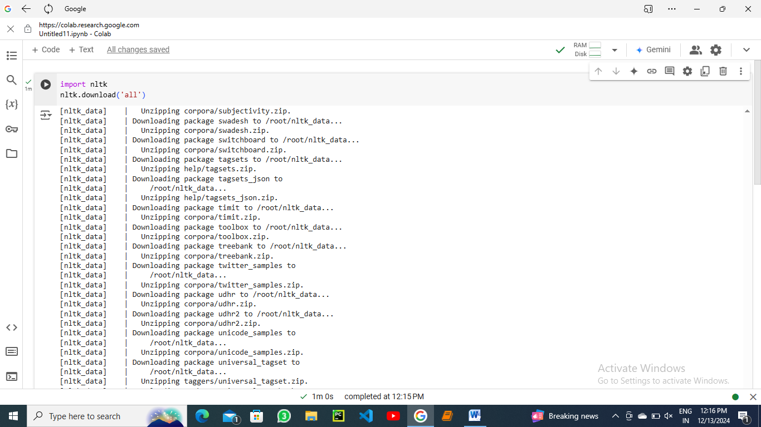

**Tokenization:- It refers to breaking down the text into smaller units.**

**Work Tokenization :- It involves break down of text into words.**

**Sentence Toknization :- It involves the breaking down of text into an individual sentence.**

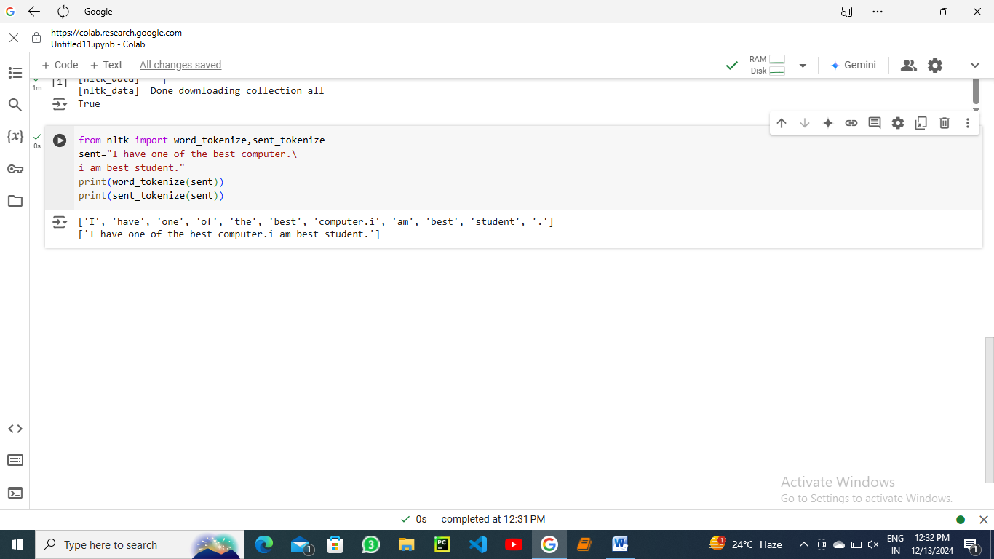

**Stemming:- stemming generates the base word from the inflected word by removing the affixes of the word. It has a set of pre-defined rules that govern the dropping of these affixes. It must be noted that stemmers might not always result in semantically meaningful base words.  Stemmers are faster and computationally less expensive than lemmatizers.**

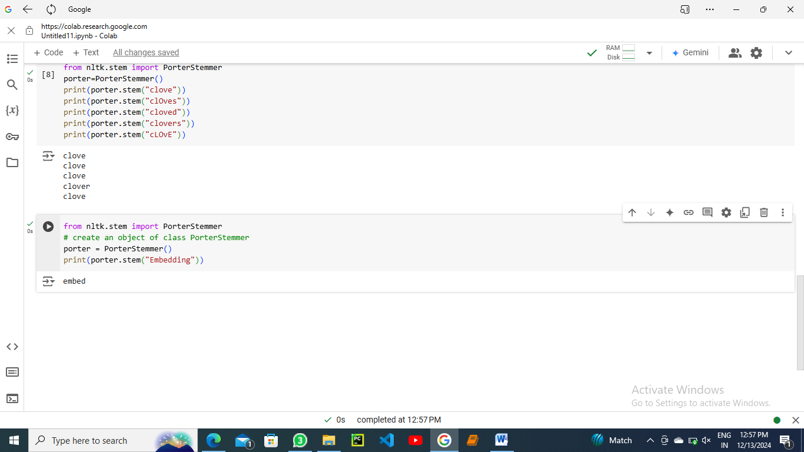

**Lemmatization :-** **Lemmatization involves grouping together the inflected forms of the same word. This way, we can reach out to the base form of any word which will be meaningful in nature. The base from here is called the Lemma. Lemmatizers are slower and computationally more expensive than stemmers.**

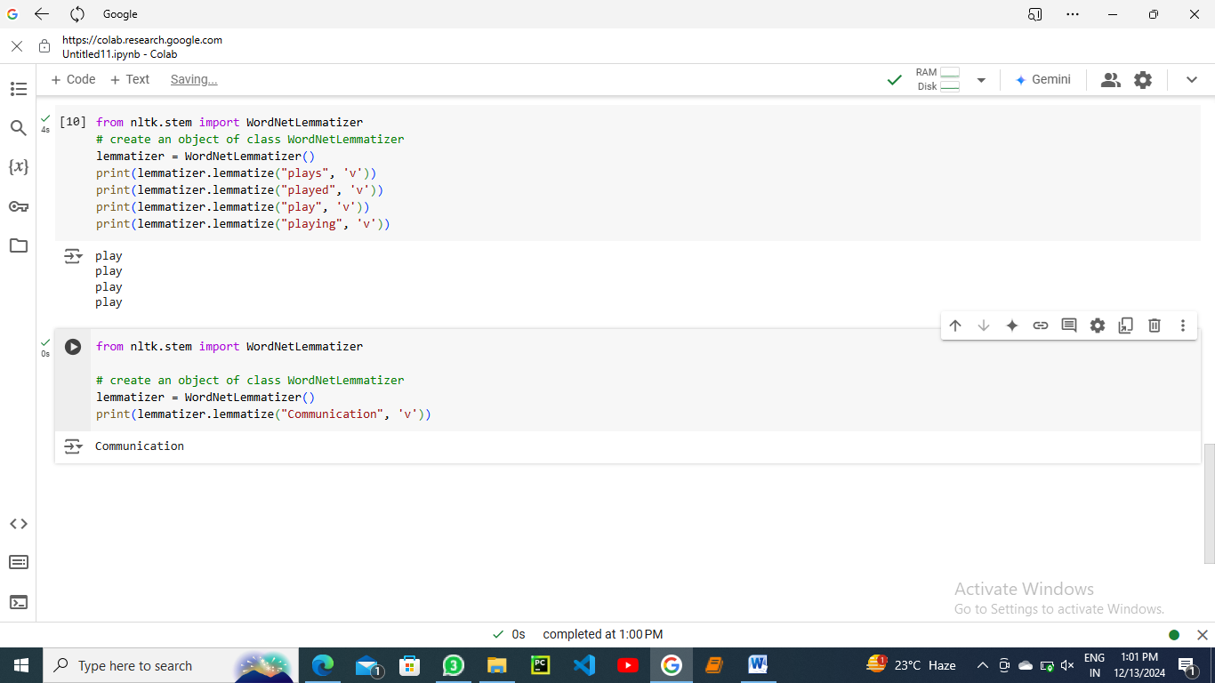

## Speech Tagging:-

**Speech (POS) tagging refers to assigning each word of a sentence to its part of speech. It is significant as it helps to give a better syntactic overview of a sentence.**

